INVENTORYSYSTEM

# ABSTRACT

Inventory management system is a system used to maintain the status of the inventory stocks. We can use it to create a new purchase order which is a requisition for the materials or goods. Using inventory management systems we can edit, manage, approve, and delete purchase orders .This system is crucial for the efficient management of a company or organization's inventory and saves a lot of time . This project is an application based on a local server which can be accessed by multiple users. It utilizes properties such as CRUD operations and ACID properties, ABC analysis, and Just-in-Time inventory system which is helpful for the business operators, where shopkeeper keep the records of purchase and sales. Mismanaged inventory means disappointed customers ,too much cash tied up in slower sale and warehouses .This inventory is eliminate paper work, human faults , manual delay and speed up process .This inventory system will have the ability to track sales and available inventory, tells a shopkeeper when it’s time to reorder and how much to purchase. Inventory management system is windows application developed for windows operating systems which focused in the area of inventory control and generate .

# TABLEOFCONTENTS

1. INTRODUCTION
   1. 1.1 Purpose
   2. 1.2 Scope
   3. 1.3 Need for system
      1. 1.3.1 Existing System & Dis -Advantages
      2. 1.3.2 Proposed System & Advantages
   4. 1.4 Architecture
2. SOFTWAREREQUIREMENTSANALYSIS&SPECIFICATINS
   1. 2.1 Product Perspective
   2. 2.2 Product Function
   3. 2.3User Characteristics
   4. 2.4Modules
   5. 2.5 Functions and non-functions
   6. 2.5.1 functional requirements
   7. 2.5.2 non-functional requirements
   8. 2.6 System specification
      1. 2.6.1 Hardware Requirements
      2. 2.6.2 Software Requirements
      3. 2.7 software development life cycle
      4. 2.7.1 waterfall model
      5. 2.8 system study
      6. 2.9 methodology and algorithm
      7. 2.10 technologies used

# 1 . INTRODUCTION

## PURPOSE:

An inventory system is a process that tracks stock, supplier and sales through an entire supply chain. Companies use inventory systems to ensure they know exactly what items they have available and the location in which they reside.

Inventory system which is helpful for the business operators, where shopkeeper keep the records of purchase and sales. This inventory is eliminate paper work, human faults manual delay and speed up process. This inventory system will have the ability to track sales and available inventory, tells a shopkeeper when it’s time to reorder and how much to purchase. Inventory management system is windows application developed for windows operating systems which focused in the area of inventory control and generate.

## 1.2. SCOPE:

Inventory systems provide detailed records of new and returned products as they're entering or leaving the warehouse to help companies organize and account for their stock. These systems can also track data such as the number of units, cost per unit, serial number, lot numbers, purchase dates and production dates.

* **Inventory control:** keeping track of stock levels ,managing re-order Points and ensuring optimal stock level.
* **Supply Chain management :** coordinating with suppliers and managing lead time store ensure timely replenishment of stack.
* **Demand forecasting:** Analysing a less data to Predict future inventory needs and adjusting Purchasing accordingly.
* **Cost management:** monitoring the costof good ssold(COGS)and over all inventors carrying costs to maximize Profitability.
* **Automation:** utilizing technology to automated asks such as re-ordering ,stock counting, and reporting to improve efficiency.

## 1.3 NEEDS FOR SYSTEM

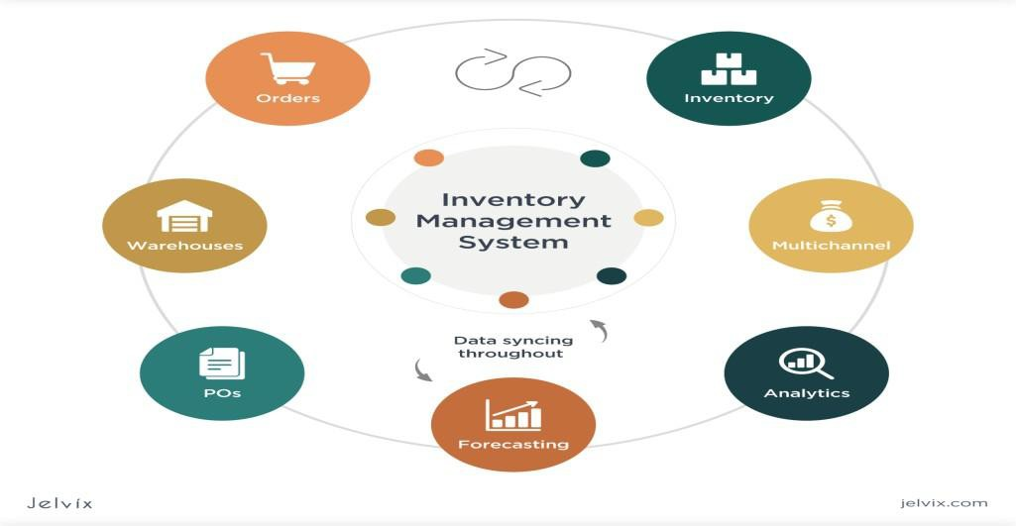A good inventory system needs to accurately track stock levels, facilitate efficient ordering and replenishment, and provide real-time visibility to ensure optimal inventory management.

* Stream lines operations
* Reduces costs
* Improves customer satisfaction
* Allows for better financial management

## 1.3.1 EXISTING SYSTEM AND ITS DRAWBACKS:

Existing inventory systems, whether manual or computerized, often struggle with inaccuracies, inefficiencies, and high costs, leading to problems like stock-outs, overstocking, and wasted resources.

### DRAWBACKS:

**Inaccurate Data and Analysis Manual Systems:**

* + - * Relyingonspreadsheetsorpaperrecordscanleadtohumanerrors,incomplete data, and difficulty in tracking inventory across different locations or departments

### Computerized Systems:

* + - * Even with software, data inaccuracies can arise from poor integration with other systems, outdated data, or errors in data entry.

### Inefficiencies and High Costs:

* + - * In accurate and forecasts ,which leads to wasteful spending ,leaving your business bloated with costs.

.

### Security Risks:

* + - * Over stocking , leading to storage costs and obsole scence ,or understanding ,causing stock-outs and missed sales.

### Lack of Real-Time Visibility :

* + - * Limited Information : Manual systems often provide limited real-time visibility into inventory levels and locations. .

## 1.3.2 PROPOSED SYSTEM AND ITS ADVANTAGES

A well-designed inventory management system, whether perpetual or periodic, offers numerous advantages, including improved forecasting, reduced operational costs, and better visibility and transparency, ultimately leading to streamlined processes and increased efficiency.

Perpetual Inventory System: This system tracks inventory in real-time , updating stock levels with each sale or purchase

### Advantages:

* **Real-time visibility :**Businesses have constant access to accurate inventory levels.
* **Improved forecasting**: Data from real-time tracking helps in better demand prediction.
* **Reduced stock-outs:** Knowing exact stock levels minimizes the risk of running out of products.
* **Better inventory control:** Real-time data allows for more efficient management of inventory.

.

## 1.4 Architecture

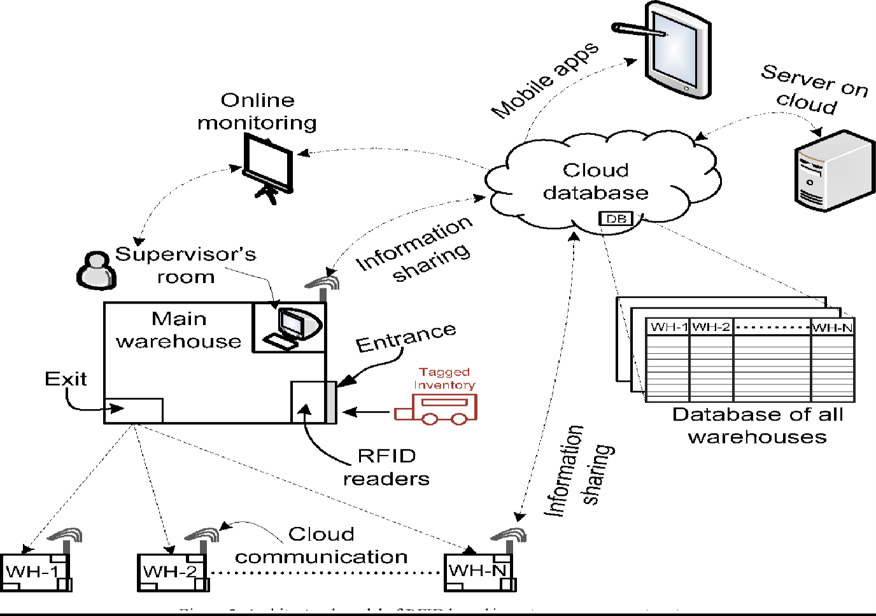

**SOFTWARE REQUIREMENTS ANALYSIS&SPECIFICATIONS**

## 2.1 PRODUCT PERSPECTIVE :

An inventory management system is how businesses track and control stock before it is sold. Whether automated or manual, inventory systems seek to bring your inventory carrying costs down while ensuring sufficient stock is available to meet customer demand.

An inventory management system (or inventory system) is the process by which you track your goods throughout your entire supply chain, from purchasing to production to end sales. It governs how you approach inventory management for your business

## 2.2 PRODUCT FUNCTIONS:

* **Inventory Tracking:** IMS software helps monitor the movement and location of inventory, ensuring real-time visibility of stock levels.
* **Inventory Control**: This involves managing and regulating the flow of goods, tracking stock levels, and minimizing stock loss.
* **Order Management**: IMS facilitates the processing of orders, including picking, packing, and shipping, ensuring efficient fulfilment.
* **Forecasting and Planning:** IMS helps predict future demand and plan inventory levels accordingly, minimizing the risk of stock outs or overstocking.
* **Storage and Warehousing**: IMS manages the storage and handling of inventory, including warehouse layout, space allocation, and inventory movement within the warehouse.

## 2.3 USERCHARACTERISTICS:

* **Software Literacy:** Users should be comfortable using computer software and databases, as inventory management systems often involve data entry, analysis, and reporting.
* **Barcode Scanning/Tagging:** with barcode scanning and tag ing systems can significantly improve efficiency in tracking and managing inventory.
* **Data Entry Accuracy:** Users need to be able to accurately input and update inventory data to maintain the integrity of the system.

## 2.4 MODULES:

### Inventory Management:

* **Item Management :** Allows users to add , edit , and manage product information (SKU, description, price, etc.).
* **Stock Tracking:** Keeps track of current inventory levels, including real time updates on stock changes.
* **Inventory Valuation :**Calculates the value of the inventory based on different costing methods (e.g., FIFO, LIFO, weighted average)
* **Inventory Adjustments:** Facilitates adjustments to inventory levels due to write-offs, returns, or other reasons.
* **Batch/Serial Number Tracking:** Allow stracking of specific batches or serial numbers for better control and traceability.
* **Barcode/ QR Code Scanning:** Enables fast and accurate inventory update using barcode or QR code technology.

### Sales Order Management:

* **Order Entry:** Allows users to create and manage sales orders.
* **Order Fulfillment:** Tracks the status of orders from placement to shipment.
* **Invoicing:** Generates invoices for sales orders.

### Reporting and Analytics:

* **Inventory Reports:** Provides reports on inventory levels, stock turnover, and other key metrics.
* **Sales Reports :** Provides reports on sales performance ,customer orders, and other sales-related data.
* **Purchase Reports:** Provides reports on purchasing activity, supplier performance, and other purchasing-related data.
* **Reduced stock-outs :** Knowing exact stock levels minimizes the risk of running out of products.
* **Better inventory control:** Real-time data allows for more efficient management of inventory.

**2.5 FUNCTIONAL AND NON FUNCTIONAL REQUIREMENTS:**

**2.5.1 Functional Requirements :**

Functional requirements define what a software system should do, as well as its features and functions. It specifies a module’s or a system’s function

Functionality is determined by comparing a set of inputs to the system under test to the system’s output. Functional requirements thereby describe a certain system outcome when a task is carried out on them by the user..

### Business regulations:

**What are your goals for** your system? What qualities are necessary for achieving your objectives?

For each function within the system, each system activity must be defined and all functional requirements types must be taken into account. As a result, this section will likely be the longest of all the others because so many needs may fit under this category.

**Corrections, changes, and cancellations of transactions :**

These specifications look at each transaction’s insertion, modification, deletion, cancellation, and error checking.

### Functions of authentication:

### They have to do with the data users divulge to the system and the amount of authentication they utilize.

### Levels of authorization:

### These operations choose who can [CRUD](https://fiware-tutorials.readthedocs.io/en/stable/crud-operations/#:~:text=Create%2C%20Read%2C%20Update%20and%20Delete,to%20using%20the%20acronym%20CRUD.) (alter, read, update, or delete) information and various system access levels.

### Audit Monitoring:

The technique of tracking crucial data is known as audit tracking.

### Certification Requirements:

### Your company may require qualifications such as security certificates to work on the system.

### 2.5.2 Non_functional requirements:

Instead of specifying “what a system should do,” the Non-functional requirements talk about “what a system should be ” (functional requirements).  Non-functional requirements describe a system’s general properties. They are also referring to as quality characteristics.

The majority of them are created from functional requirements that are based on feedback from customers and other stakeholders. The Non-functional requirement focuses more on overall system behavior than on a specific function.

### Extensibility

It is the capacity to extend a system and the amount of work required to do so. Utilize Nvntri to become more efficient and save time.

### Availability

This feature specifies how long the system operates, how long it takes to fix a problem, and how long it takes between lapses. Let the Nvntri make it better for you, the system must be available for use as much as possible and that downtime must be minimized.

### Reliability

The chance and percentage of the software working without failure for a given number of uses or period of time is referred to as reliability. Manage things stress-free, to become more efficient and save time with Nvntri.

**2.6 System Specification:**

### 2.6.1 Hardware Requirements Server:

#### 1. ****Server(s)****

* **Purpose:**  Host the IMS application and database.
* **Specs:** 
  + Processor: Multi-core CPU (e.g., Intel Xeon or AMD EPYC)
  + RAM: 16 GB or more (depending on user load)
  + Storage: SSD with sufficient capacity (at least 500 GB) for database and backups
  + Network: Reliable Ethernet connection (1 Gbps recommended)
  + OS: Windows Server, Linux, or cloud-based server.

#### 2. ****Client Machines / Workstations****

* **Purpose:** For users to access the IMS software (via desktop app or web browser).
* **Specs:**
  + Processor: Dual-core or better
  + RAM: 4 GB minimum
  + Storage: 100 GB or more (if locally installed software)
  + OS: Windows, macOS, or Linux

### 2.6.2 Software Requirements:

#### 1. ****Operating System****

* For **Server**:
  + Windows Server (e.g., 2019, 2022)
  + Linux distributions (Ubuntu Server, CentOS, Debian)
  + Cloud platforms (AWS, Azure, Google Cloud) if cloud-hosted
* For **Client Machines**:

Windows 10/11, macOS, or Linux (depending on software compatibility)

### .

**2.7 Software Development Life Cycle (SDLC):**

**2.7.1 Waterfall Model :**

The project follows the Waterfall model, a linear and sequential approach:

**Requirement Analysis**: Gathering all system requirements.

**System Design**: Designing system architecture and components.

**Implementation**: Coding and development of modules.

**Testing:** Verifying and validating the system.

**Deployment**: Launching the system for end-users.

### 2.8 System Study:

### The study involved analyzing existing inventory management methods, identifying bottlenecks like manual errors and delays, and defining system goals to automate and improve accuracy.

### IMG-20250606-WA0024.jpg

### 2.9 Methodology and Algorithm:

### The system uses algorithms for stock management such as:

### Reorder Level Checking: When stock quantity = reorder level, trigger alert.

### Stock Update Algorithm: Automatically adjust stock quantities on sales or purchases

### Report Generation: Query database and summarize inventory status.

### 2.10 Technology Used Frontend:

### React.js or Angular for responsive UI.

### Backend: Node.js with Express or Django framework.

### Database: MySQL for reliable data storage.

### Version Control: Git for source code management.

### Deployment: Hosted on cloud platforms like AWS or Azure.

**Normalization** in inventory management refers to the process of organizing inventory data and processes to improve efficiency, reduce redundancy, and ensure consistency. It often involves standardizing inventory records, categorizing items systematically, and streamlining procedures to better control stock levels, reduce errors, and optimize storage and handling.

### Why Normalize Inventory Management?

* **Avoid Duplicate Records:** Prevent multiple entries for the same item.
* **Improve Accuracy:** Ensure inventory data is consistent and reliable.
* **Optimize Stock Levels:** Maintain optimal stock to avoid overstocking or stockouts.
* **Simplify Reporting:** Easier and clearer inventory reports.
* **Enhance Decision Making:** Clear data helps in forecasting and planning.

### How is Normalization Applied?

* **Standardizing Item Names and Codes:** Use unique SKUs or barcodes for each item.
* **Classifying Inventory:** Categorize items by type, usage, or priority (e.g., raw materials, finished goods).
* **Unit of Measure Consistency:** Ensure uniform units (e.g., all in kilograms or pieces).
* **Data Structuring:** Organize inventory data in a database to minimize duplication and errors.
* **Reviewing Inventory Policies:** Standardize reorder points, safety stock levels, and lead times.

### Example:

Without normalization, you might have the same product entered multiple ways:

* "Blue Widget"
* "blue widget"
* "Blue-widget"

After normalization, all are recorded as **"Blue Widget"** with a unique SKU, ensuring accurate tracking and reporting.